Sisters Health and Rights Initiative (SHRI) – Baseline Report

The research was conducted, and the policy brief was written by Frank Kyei-Arthur (PhD): the assignment came from SCEF and send a smile e.V.

## Executive Summary

Every individual, including sexually exploited women, has the right to make free and informed decisions about their sexual and reproductive health and lives. The Street Children Empowerment Foundation and send a smile e.V. initiated the Sisters Health and Rights Initiative (SHRI) in 2023 to safeguard vulnerable women and girls. SHRI aims to educate vulnerable and sexually exploited women and girls about their sexual and reproductive health and rights so they can make autonomous choices about their bodies and become more economically and emotionally independent.

## Key messages and recommendations

* Alcohol and drug consumption were prevalent among sexually exploited women.
* Condoms and implants were the main contraception methods used by sexually exploited women.
* Sexually exploited women need access to STI and cervical cancer screening.
* Recommendation 1: SHRI should provide psychological counselling to sexually exploited women to help reduce their consumption of alcohol and drugs.
* Recommendation 2: Sexually exploited women's access to peer educators should be enhanced.

## About the project

The Convention on the Elimination of All Forms of Discrimination Against Women (CEDAW) and the Universal Declaration of Human Rights seek to protect the rights of vulnerable populations, including sexually exploited women and girls. The rights of sexually exploited women and girls include their right to sexual and reproductive health services and absence from violence.

To safeguard vulnerable women and girls, the Street Children Empowerment Foundation and send a smile e.V. initiated the Sisters Health and Rights Initiative (SHRI) in 2023. The general objective of SHRI is to educate vulnerable and sexually exploited women and girls about their sexual and reproductive health and rights so they can make autonomous choices about their bodies and become more economically and emotionally independent. The specific objectives include:

* To provide SRHR information, education and services.

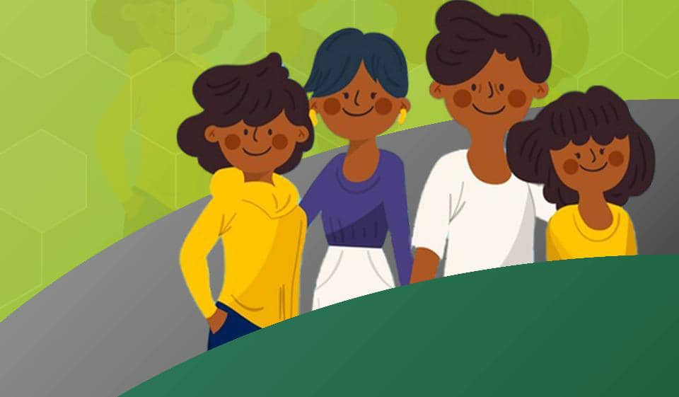

* To support women in proceeding with their education or to encourage them to find a legal source of revenue.
* To provide mental health care for girl's and women's wellbeing.
* To advocate for women's rights and to create awareness about different problem areas of SRHR in the communities.
* To train survivors of sexual exploitation to become mentors for other women of their communities and SRHR experts.

# Methodology

A mixed-method approach was used for this project. The quantitative data were collected from sexually exploited women in James Town Area, Bolla top - Sawdust, Timber market, and Oliver Twist. In total, 267 sexually exploited women were interviewed. The qualitative data were collected from six (6) peer educators and two (2) health workers. Sexually exploited women were interviewed using a semi-structured questionnaire, while an interview guide was used to interview peer educators and health workers.

The data collection was conducted between 18th April and 30th August 2023. All participants gave their consent before their data were collected. Participants were assured of confidentiality and anonymity. The qualitative data was analysed using the Statistical Package for Social Sciences (SPSS) version 25, while the qualitative data was analysed thematically. A validation workshop was held on 5th October 2023 to validate the findings of the study.

## Key findings

* About 22% of sexually exploited women indicated that they have been making money or goods in exchange for sex or sexual favours for more than 4 years (49 months and above).
* About 37% of sexually exploited women had a source of income apart from engaging in prostitution.
* About 57% of sexually exploited women consumed alcohol to engage in prostitution, while 49% took drugs (e.g., marijuana, cocaine, etc.).
* Also, 28.5% of sexually exploited women worked under the control of someone (e.g., pimp, madam, manager, etc.).
* Among those who worked under the control of someone, about 37% had the opportunity to make decisions about themselves, including keeping their money.
* Condoms (41.9%) and implants (17.2%) were the main contraception methods used by sexually exploited women.
* About 14% of sexually exploited women have ever tested for cervical cancer, while two-fifth (40.1%) have ever had forced sex during their sexual work.
* 23% of sexually exploited women had never tested for HIV.
* About 38% of sexually exploited women had never had contact with a peer educator.
* The main sexual and reproductive health services received by sexually exploited women were HIV testing and counselling (37.6%), and contraceptives (28.6%).
* Health workers mentioned that sexually exploited women receive pre-exposure prophylaxis, hepatitis B testing, condoms, and lubricants.
* Most sexually exploited women knew their human rights (62.2%) and sexual and reproductive health rights (56.6%).
* Eight out of 10 sexually exploited women want to exit prostitution.
* Most sexually exploited women wanted to learn hairdressing (42.7%) and makeup (32.8%).

Figure 1: Contraception methods currently used by sexually exploited women

Figure 2: Have you ever tested for cervical cancer and ever had forced sex during work

Figure 3: Last time sexually exploited women tested for HIV

Figure 4: Sexual and reproductive health services and rights

## Conclusions and recommendations

The baseline data collection demonstrates that most sexually exploited women knew their human rights and sexual and reproductive health rights. Sexually exploited women need STI and cervical cancer screening and easy access to health care services to enhance their health. Also, the consumption of alcohol and drugs were high among sexually exploited women.

* SHRI should provide regular STI and cervical cancer screening and enhance sexually exploited women's access to health care services to improve their health.
* SHRI should provide psychological counselling to sexually exploited women since most consume alcohol and drugs to engage in prostitution.
* SHRI should strengthen sexually exploited women's knowledge of human and sexual and reproductive health rights.
* SHRI should provide skills training for sexually exploited women to pave way for alternative profession.
* SHRI should increase sexually exploited women's access to peer educators.
* SHRI should provide both male and female condoms to sexually exploited women.

### Acknowledgements

We are grateful to all the participants in this study. We are also thankful to all donors who made this project a reality.

**Publication details:** © SCEF, send a smile e.V., October 2024.

 